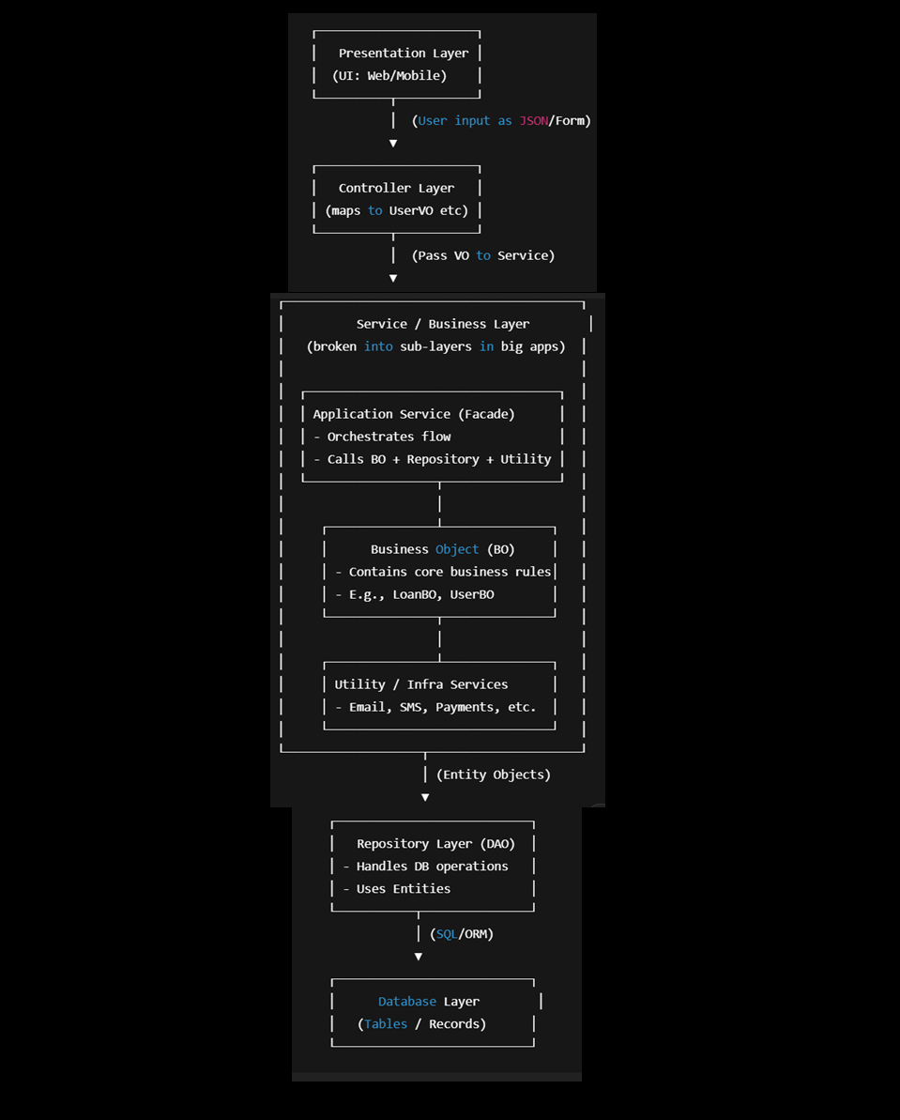

### 🔹 What is a VO (Value Object)?

* A **VO (Value Object)** is a **simple Java class** that is mainly used to **hold data temporarily**.
* It usually contains **variables (fields)** with their **getters and setters**.
* It does **not** contain business logic (calculations or processing).
* Think of VO as a **data carrier** between different layers of your application.

### 🔹 Where is VO used?

In a typical **Spring Boot web application**, the flow of data is like this:

1. **UI (Frontend / Client)** → sends data (example: form submission, JSON request).
2. **Controller** → receives that data and maps it to a **VO object**.
3. **Service Layer** → receives the VO object from the Controller, then performs business logic.
4. (Later) → this data may be passed to DAO/Repository layer to save into DB.

### 🔹 The Flow in Detail

#### 1. **Data comes from UI**

* Suppose the UI (like Angular/React or even Postman) sends a JSON request:

{

"name": "Pavan",

"email": "pavan@gmail.com",

"age": 25

}

#### 2. **Controller receives the data**

* In Spring Boot, we write a **Controller class** with a method.
* That method receives the data using an annotation: **@RequestBody**.
* Spring Boot automatically maps the incoming JSON data into the **VO object**.

👉 Example:

@RestController

@RequestMapping("/user")

public class UserController {

@PostMapping("/save")

public String saveUser(@RequestBody UserVO userVO) {

// userVO now contains the data from UI (via JSON)

return "User saved: " + userVO.getName();

}

}

#### 3. **How the mapping happens internally**

* The JSON keys (name, email, age) are matched with the **fields in VO**.
* Spring uses the **setters of VO** to insert values:
  + JSON "name": "Pavan" → userVO.setName("Pavan")
  + JSON "email": "pavan@gmail.com" → userVO.setEmail("pavan@gmail.com")
  + JSON "age": 25 → userVO.setAge(25)

So, by the time your controller method runs, you can already get values using userVO.getName(), userVO.getEmail(), etc.

### 🔹 4. **VO definition**

public class UserVO {

private String name;

private String email;

private int age;

// Getters & Setters

public String getName() { return name; }

public void setName(String name) { this.name = name; }

public String getEmail() { return email; }

public void setEmail(String email) { this.email = email; }

public int getAge() { return age; }

public void setAge(int age) { this.age = age; }

}

### 🔹 5. **VO sent to Service Layer**

* After the controller gets the VO object, it usually sends it to the **Service Layer**.
* Example:

@RestController

@RequestMapping("/user")

public class UserController {

private final UserService userService;

// constructor injection

public UserController(UserService userService) {

this.userService = userService;

}

@PostMapping("/save")

public String saveUser(@RequestBody UserVO userVO) {

// send VO to service layer

return userService.saveUser(userVO);

}

}

@Service

public class UserService {

public String saveUser(UserVO userVO) {

// Business logic happens here

// Example: save user to DB (not shown now)

return "User saved with name: " + userVO.getName();

}

}

### 🔹 Summary (Self-Explanatory Notes)

1. **VO is a data carrier** – it just holds values with getters and setters.
2. **UI → Controller → Service** → VO travels along this path.
3. When data comes from **UI**, the **@RequestBody annotation** tells Spring Boot to:
   * Read the incoming JSON.
   * Match JSON fields with VO fields.
   * Call VO **setters** to set the values.
4. From Controller, VO is passed to **Service Layer** where business logic is applied.
5. Using VO makes the code clean, organized, and easy to maintain.

**2. Application Service Layer**

### 🔹 What It Does (Step by Step)

1. **Receives VO from Controller**
   * When the Controller gets data from UI, it is mapped to a **VO (Value Object)**.
   * This VO is passed to the Application Service Layer.
2. **Does Initial / Partial Processing**
   * Before deep business logic, the Application Service Layer performs some **basic tasks** like:
     + **Input validation** (e.g., checking if fields are empty, format of email, mobile number, etc.).
     + **Simple transformations** (e.g., trimming strings, formatting dates).
     + **Applying security checks** (e.g., user roles, permissions).
   * These are **lightweight checks** done before sending data for heavy business logic.
3. **Converts VO → BO**
   * After validation, the VO (which is UI-friendly) is **converted into BO (Business Object)**.
   * **Reason:**
     + VO is designed for data transfer from UI → Controller (simple structure).
     + BO is designed to carry **business-related attributes and behavior** (logic-ready).
   * Example:
     + VO: UserVO { name, email, password }
     + BO: UserBO { name, email, password, isEligibleForLoan(), calculateCreditScore() }
4. **Hands Over BO to BO Layer**
   * Once VO is converted into BO, the **Application Service Layer passes this BO to the BO Layer**.
   * The BO Layer will now apply **core business rules** (like interest calculation, tax rules, eligibility criteria).

# 📌 BO Layer (Business Object Layer)

The **BO Layer** is the place where the **real business logic** of the application lives.  
While the **Application Service Layer** only does partial checks and conversions, the **BO Layer** is responsible for executing the actual business rules that define how the system works.

### 🔹 What It Does (Step by Step)

**1. Receives BO from Application Service Layer**

* The Application Service Layer has already converted **VO → BO**.
* This **BO (structured for business logic)** is passed to the BO Layer.

**2. Applies Core Business Rules / Logic**

* The BO Layer contains methods and functions that implement **business policies, calculations, and decision-making rules**.
* Examples:
  + **Banking System** → Calculate interest, check minimum balance, apply transaction charges.
  + **E-commerce System** → Apply discount rules, calculate shipping costs, validate coupon codes.
  + **Healthcare System** → Verify patient eligibility for insurance, calculate treatment cost, generate reports.
* These rules are the **heart of the system** because they directly represent the **business requirements**.

**3. Uses Utility Layer if Required**

* If, during processing, the BO Layer needs **helper functions** (that are not core business rules but supporting functions),  
  it calls the **Utility Layer**.
* Examples:
  + Date formatting (DateUtil.formatDate()).
  + Generating OTP (OtpUtil.generateOtp()).
  + Encryption/Decryption for sensitive data.
  + Logging and auditing.
* This ensures the BO Layer focuses **only on business rules**, while technical/helper logic is reused from Utility Layer.

**4. Encapsulates Business Behavior**

* A **BO (Business Object)** is not just data;  
  it also has **methods (functions)** that perform operations related to that data.
* Example:

class LoanBO {

private double principal;

private double rate;

private int duration;

// Business Rule: Calculate EMI

public double calculateEMI() {

return (principal * rate * duration) / 100;

}

}

* Notice how the **rule for EMI calculation lives inside BO itself**.

**5. Returns the Processed BO back to Application Service Layer**

* After applying rules (and using Utility Layer if needed), the **updated BO** (with calculated values, decisions, or statuses) is returned to Application Service Layer.

# 📌 Flow: BO → Application Layer → Entity → Repository

1. **BO Layer → Application Service Layer**
   * BO Layer finishes business logic (e.g., calculates EMI, applies discounts, etc.).
   * It gives back the **processed BO** to the Application Service Layer.
2. **Application Service Layer (Conversion Step)**
   * The repository/DAO does **not work with BO**, it works with **Entity/Model objects** (because they are mapped to DB tables).
   * So, Application Layer **converts BO → Entity (Model class object)**.

Example:

LoanEntity entity = new LoanEntity();

entity.setPrincipal(loanBO.getPrincipal());

entity.setRate(loanBO.getRate());

entity.setDuration(loanBO.getDuration());

entity.setEmi(loanBO.getCalculatedEmi());

1. **Application Layer → Repository/DAO Layer**
   * Now, the **Entity object** is passed to the Repository/DAO for DB persistence.
   * Example:
2. loanRepository.save(entity);
3. **Repository → Database**
   * Repository/DAO translates the entity into SQL queries and stores/updates/fetches data in the database.

# 📌 Data Flow After DB Interaction

1. **DB → Repository/DAO**
   * Database only deals with **raw table rows**.
   * JPA/Hibernate automatically maps these rows into **Entity/Model objects**.
   * ✅ So Repository **always works with Entity objects**, not DTO or BO.
2. **Repository/DAO → Application Layer**
   * Repository returns the **Entity object(s)** to the Application Service Layer.
3. **Application Service Layer → DTO Conversion**
   * The Application Layer converts the **Entity → DTO** (because DTO is safe and UI-friendly).
   * Example:
     + Entity may contain passwordHash, createdAt, updatedAt → but UI doesn’t need them.
     + So, DTO will only have username, email.
4. **Application Service Layer → Controller → UI**
   * The DTO is passed to the Controller.
   * Controller sends the DTO as JSON/XML to the UI.